Unit: Force & Motion
Topic: Newton’s First Law - Questions
Answer all questions on a separate sheet of paper.

1. Does the law of inertia pertain to moving objects, objects at rest or both?

both
2. If you were in a spaceship and fired a cannonball into frictionless space, how much force would have to be exerted on the ball to keep it moving once it has left the spaceship?

None

3. An elephant and a mouse both have the same weight - zero - in “gravitation-free” space. If they were moving toward you with the same speed, would they bump into you with the same effect? EXPLAIN!

NO! The larger mass of the elephant means it has a larger inertia. This means it will be more difficult to change its state of motion and will therefore “run” you over.

4. In the cabin of a jetliner that cruises at 600 km/h, a pillow drops from an overhead rack. Does a passenger walking up the aisle have to worry about the pillow slamming into her and knocking her over? Explain.

NO. Since both are in the “same” relative motion, the pillow will simply fall to the floor.

5. Many automobile passengers have suffered neck injuries when struck by cars from behind. How does Newton's law of inertia apply here? How do headrests help to guard against this type of injury?

When hit from behind, the car accelerates forward as does the body since it is pushed by the seat. The head however, unless there is a headrest, tries to “stay put.” This results in the head “snapping back”.

6. Suppose you place a ball in the middle of a wagon, and then accelerate the wagon forward. Describe the motion of the ball relative to the ground?
The ball maintains its position.
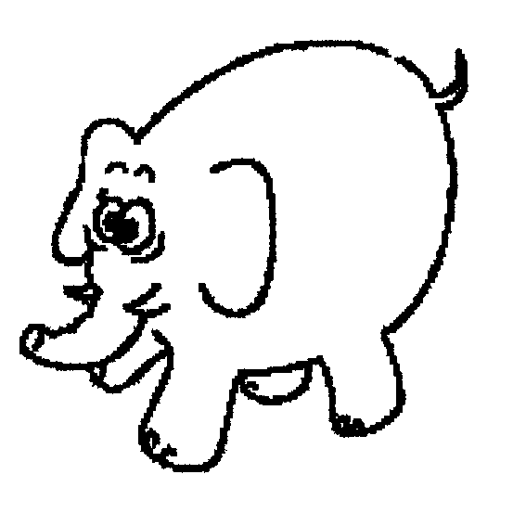
- Describe its motion relative to the wagon?

The ball rolls to the back of the wagon.

7. If an elephant were chasing you, its enormous mass would be most threatening. But if you zigzagged, its mass would be to your advantage. Why?

Its large mass means it has large inertia resulting in the elephant having a difficult time changing its direction.

8. Two closed containers look the same, but one is packed with lead and the other with a few feathers. How could you determine which has more mass if you and the containers were orbiting in a weightless condition in outer space?

Shake them.

9. If suddenly the force of gravity of the sun stopped acting on the planets, in what kind of path would the planets move?

Straight lines.
10. A helium balloon is held by its string in a car with the windows rolled up. The car, initially at rest, accelerates forward. Which direction does the balloon move? Explain.

Forward. A helium balloon floats to the top of the atmosphere. As the car accelerates forward, the air in the car “hangs back” due to its inertia, causing the balloon to “rise” to the “top” of the atmosphere.

